Experiment 9 (1st Part)

Definiton : Design a simple list report in IBM Cognos with formatted and sorted columns using personal data sources.
Outcomes/Learning : Proficiency in fundamental Cognos report design, data source integration, and basic visualization formatting techniques.
Required Tool: IBM Cognos Analytics (Report/Dashboarding Environment).

Working: A seven-step professional process covering report selection, data integration, content population, aesthetic refinement, and final HTML report execution.
Step 1 : Select the appropriate visualization type—in this case, a List—from the options presented in the center of the screen to begin the report creation process.
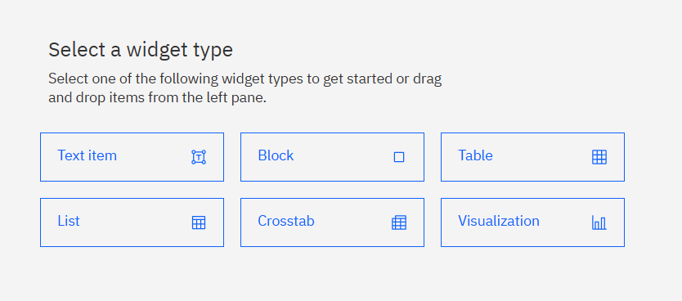

Step 2 : Define descriptive names for both the List object and its associated Query. Confirm the properties to initialize the new List visualization.

Step 3 : Navigate the source tree on the left panel and specify the required data package or module (e.g., Samples > Team Content > Data > Great Outdoors Data Module).
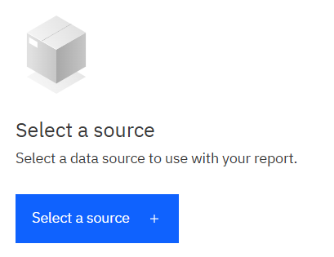

Step 4 : Drag and drop the necessary data elements (columns, fields) from the chosen data source into the List object to populate the report structure.
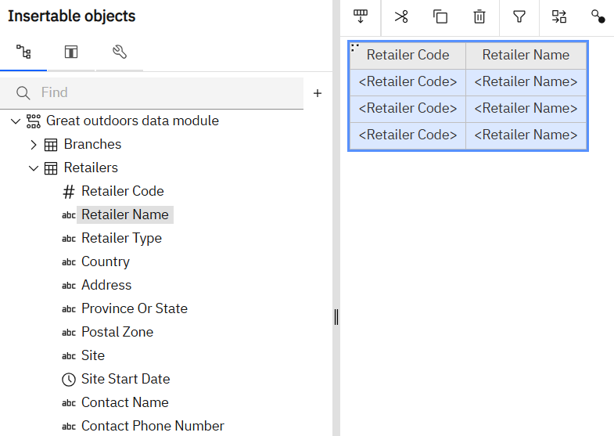

Step 5 : Utilize the formatting icons in the toolbar to enhance the List's presentation, including applying colors, advanced formatting rules, and Highlighting for simplified and attractive data consumption.
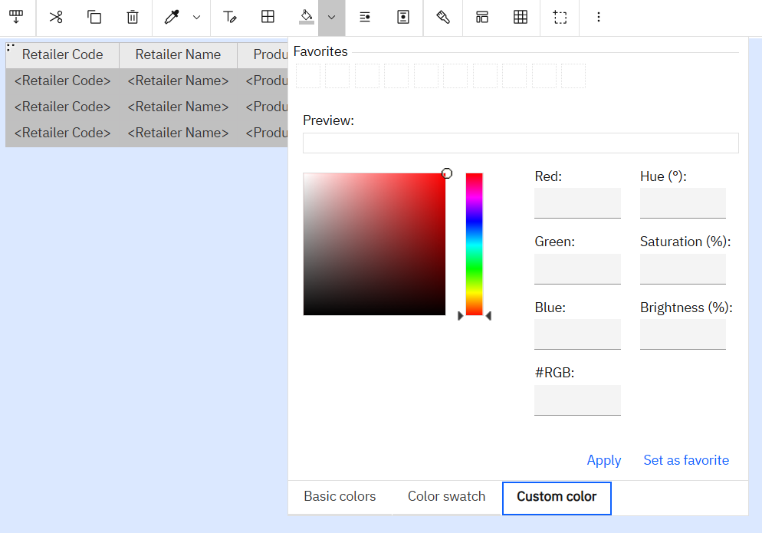
Step 6 : Change the Page Editor view to Page Preview (typically located on the right side panel) to review the visualization populated with actual data, ensuring content accuracy and layout coherence.
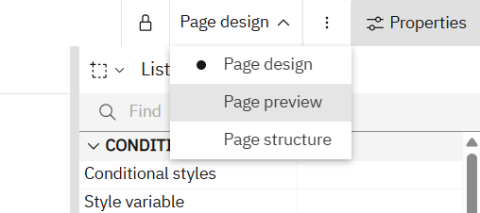
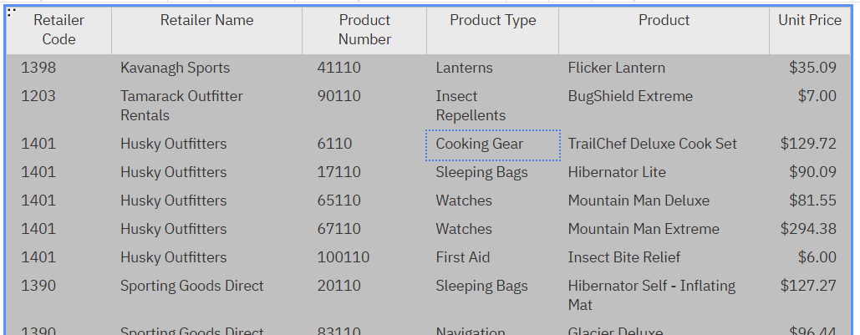
Steo 7 : Select the Run HTML button from the main ribbon to execute the report. This process generates the underlying HTML code and displays the final, interactive output as an end-user would view it.
